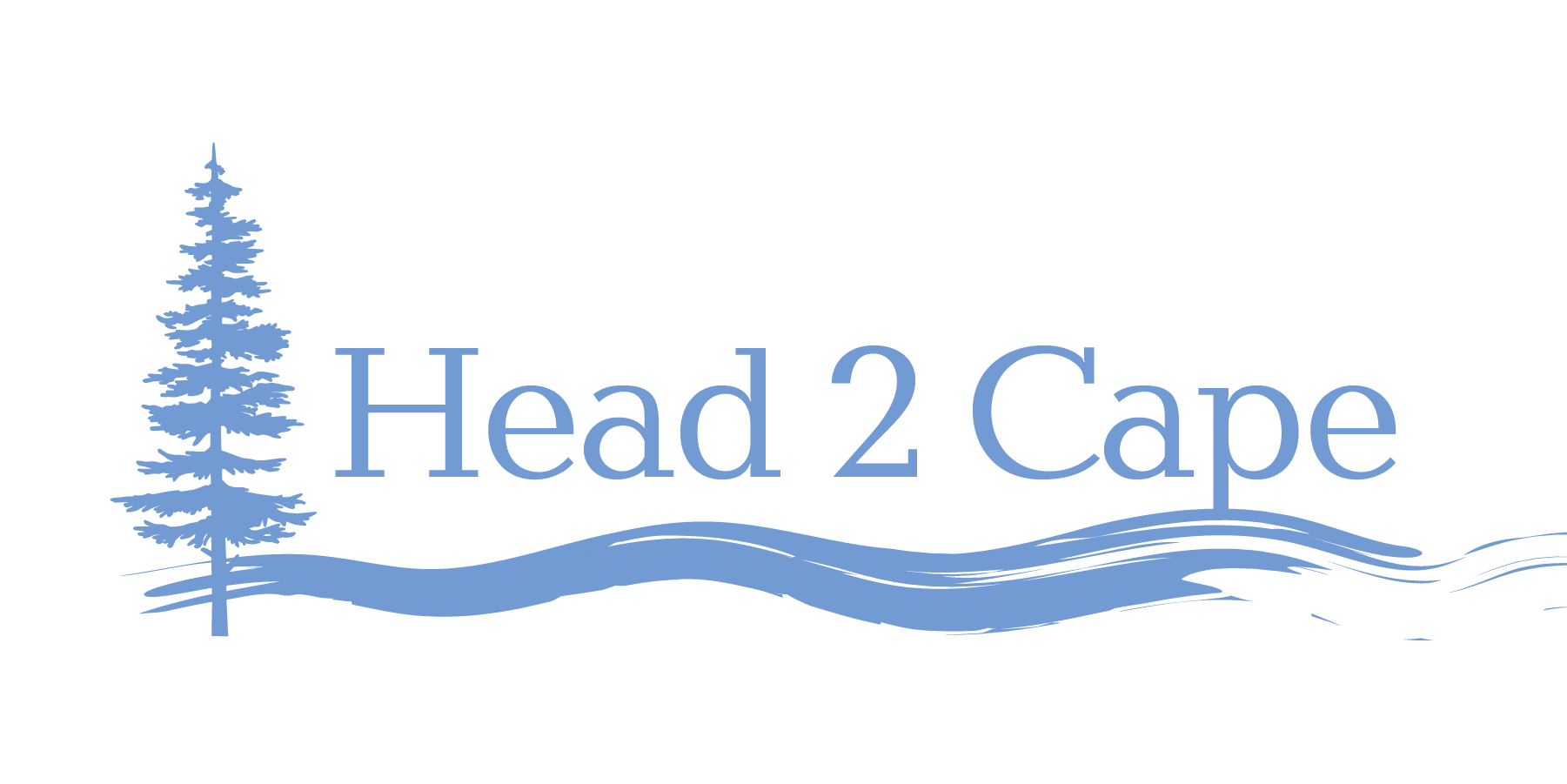

AGENDA

Mid-Coast Water Planning Partnership Strategy Development

Session #2: Enhanced Regional Collaboration
January 13, 2021 8:00am–9:30am

Please join my meeting from your computer, tablet or smartphone.
https://global.gotomeeting.com/join/756758117

Objective: Develop draft strategies that address the key issues associated with Enhanced Regional Cooperation in the Mid-Coast region of Oregon.

Enhanced Regional Collaboration
- Mid-Coast water providers share the need for system resilience and reliable source water quantity and quality. Regular coordination and collaboration among water providers can improve access to resources and funding to support this need.

8:30am–8:35am Welcome, introductions

8:35am–8:40am Review of key objectives, definition, and key issues from Step 3 of the Planning Process

8:40am–9:10am Review/affirm/edit draft strategies/actions discussed by partners to date, and consider other potential actions.

9:10am–9:25am Consider additional objectives and strategies to address Enhanced Regional Collaboration goals.

9:25am–9:30am Summarize, discuss goals for next week, and adjourn

Table 1. States, objectives, and actions to address key water issues in the Mid-Coast region of Oregon.
States | Objectives | Actions Discussed by Partnership To Date | Potential Actions to Consider/Incorporate
Lack of access to resources and funding to enhance system resilience and reliable source water quantity and quality. | Build capacity of constituents to advocate for state resources and funding. | - Coordinate watershed and water system tours to increase awareness and understanding of regional and local water issues.  - Offer information-sharing workshops for landowners.  - Provide technical assistance to manage residential and/or outdoor water audit programs. | 1. Create an evaluation component, such as a report card, that provides updates to the public annually. Highlight priorities for the coming year and opportunities to get involved. Make water system reliability and resilience a public campaign to keep these issues at the forefront of minds and public efforts.  2. Explore organizational options for Mid-Coast Water Conservation Consortium that would enable entity to prioritize and fund infrastructure projects throughout the region on behalf of members.
Limited communication among regional water providers. | Promote opportunities to improve communications, share knowledge, and pool resources. | - Improve collaboration among water suppliers.  - Develop a regional Mid-Coast water conservation consortium that enhances water conservation, increases resiliency during shortages and emergencies, and pools resources of multiple water providers. | - Develop tiered communication trees to address: a) typical support needs (materials, expertise, spare hands); b) response to localized emergencies affecting 1 or several Public Water Systems (but not a majority); and c) Cascadia Subduction Zone quake, volcanic eruption, regional wildfire. Provide communication alternatives for inoperable phone/internet (HAM resources; meeting locations and days/times).
Insufficient monitoring of stream flow and water quality. | Improve the effectiveness of water quality and quantity monitoring programs throughout the region. | - Fully fund, install, and monitor real-time stream gauging stations throughout region. | - Identify priority locations and times of year where gauging and stream flow measurements are needed most.  - Develop coordinated network of people conducting stream flow monitoring and water quality monitoring to share resources and data. Explore cost-effective ways to incorporate volunteers in data collection to complement gauging network.  - Develop a database for data entry and access by multiple parties.

