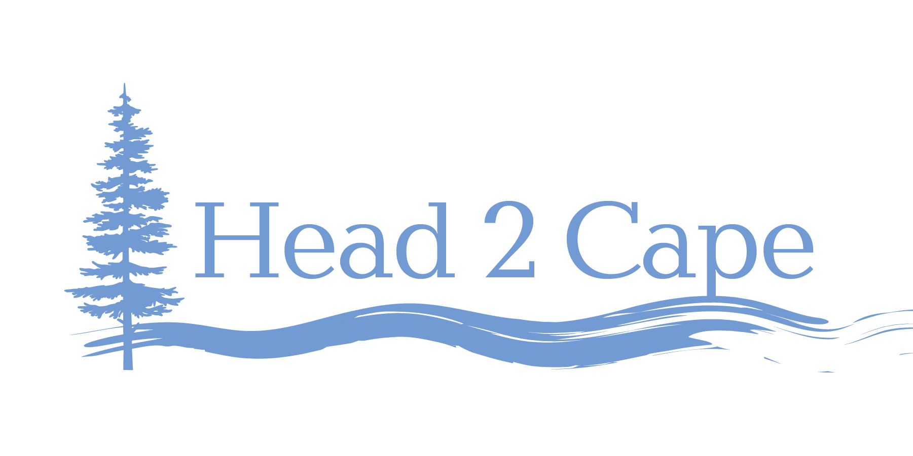

AGENDA

Mid-Coast Water Planning Partnership Strategy Development

Session #6: Source Water Development and Protection
February 10, 2021 8:00am–9:30am

Please join my meeting from your computer, tablet or smartphone.
https://global.gotomeeting.com/join/756758117

Objective: Develop draft strategies that address the key issues associated with Source Water Development and Protection in the Mid-Coast region of Oregon.

Source Water Development and Protection
- Some municipal and special district water providers are currently facing water shortages late in the summer and during dry years.
- Rural residents and landowners, agricultural irrigators, and industrial water users currently experience chronic seasonal water scarcity due to limited water availability.
- Low stream flow and high temperatures in the summer months, and high turbidity due to winter storms, pose challenges for drinking water suppliers to meet state and federal regulations to provide safe drinking water.
- Self-supplied rural residents are increasingly concerned about drinking water quality and need adequate and timely data to determine regional, local, or site-specific water quality contamination issues that may pose a health risk.

8:30am–8:35am Welcome, introductions

8:35am–8:40am Review of key objectives, definition, and key issues from Step 3 of the Planning Process

8:40am–9:10am Review/affirm/edit draft strategies/actions discussed by partners to date, and consider other potential actions.

9:10am–9:25am Consider additional objectives and strategies to address Source Water Development and Protection goals.

9:25am–9:30am Summarize, discuss goals for next week, and adjourn

Table 1. States, objectives, and actions to address key water issues in the Mid-Coast region of Oregon.
States | Objectives | Actions Discussed by Partnership To Date | Potential Actions to Consider/Incorporate
Impaired Some Mid-Coast watersrivers and streams dowater quality – Does not meet Oregon and federal water quality standards. for temperature, dissolved oxygen, and turbidity. | Assess the levels and presence/absence of toxics in Mid-Coast waters and describe negative effects to human health.  Reduce the potential effects of toxics chemicals, pesticides, herbicides, and pharmaceuticals, and wastewater land applications on water quality.  Reduce coliform and E. coli bacteria in Mid-Coast waters by addressing the source.  Harmful algal blooms  *(chemicals, pesticides, herbicides, pharmaceuticals, etc.) | - Use fewer herbicides and pesticides, and enhance riparian buffers.  - Encourage longer forest rotations, improve riparian buffers, and implement more erosion control practices.  - Assess the impacts of biosolids on local well water quality, and develop a suite of strategies to minimize effects.  - Conduct comprehensive and ongoing water testing.  - Implement best management practices to reduce the levels of toxics in water. | - Manage urban runoff (both stormwater and dry-weather).  - Reduce lawn fertilizer use.  - Reduce/eliminate mowing near streams and ponds  - Reduce erosion and exposed soils on all properties.  - Implement monitoring programs that collect water samples to identify pollutant sources (location, source, practices influencing input, transport and fate of pollutants). Use results to prioritize outreach and incentive programs to modify practices.  - Notify and educate the public re: the need for source water protection measures.  - Encourage use of, and promote BMPs, for pollution prevention and waste reduction.  - Sponsor hazardous waste/unused chemical collection (e.g., permanent locations or one-day events to collect hazardous waste from community residents)  - Develop spill response plans to facilitate quick response and notifications should a spill occur.  - Acquire land or rights to development to obtain community ownership of critical land areas managed for water quality protection.
Mid-Coast water supplies are inadequate to meet the water supply needs of Mid-Coast communities.

