Mid-Coast Water Planning Partnership
Coordinating Committee
Meeting Minutes
December 10, 2020, 9:00 – 10:00 am
Meeting Attendance:
Mid-Coast Coordinating Committee
Harmony Burright – OWRD
Adam Denlinger – Seal Rock Water District
Alan Fujishin – Gibson Farms
Kaety Jacobson – Lincoln City
Chris Janigo – City of Newport
Penelope Kaczmarek – Coastal Resident
David Rupp – Oregon State University
Alexandria Scott – Local Planning Coordinator
Paul Schutyema – Lincoln County Economic Development Alliance
Stan van de Wetering – Confederated Tribes of Siletz Indians of Oregon

Consulting Project Team
Sam Chan – Oregon Sea Grant
Lisa DeBruyckere – Creative Resource Strategies, LLC
Lisa Gaines – Institute for Natural Resources
Derek Godwin – Oregon State University Extension Services
Marc Rempel – Oregon State Library
Janine Salwasser – Institute for Natural Resources (Oregon Explorer)
Decision Items
- The CC agreed to the use of Informed Consent as a model for decision making; the next step is for the Project Team to suggest draft edits to the charter to institutionalize informed consent language in the document.

Meeting Summary

Project Team November Progress Report, Partnership Newsletter
The Coordinating Committee was given an opportunity to provide any comments on the Project Team’s November Progress Report and November Partnership newsletter.

Water Report – Institute for Natural Resources
Janine Salwasser shared the draft template for the water report, and there was discussion about key next steps, which included sharing the document in Box and asking people to comment on categories they considered priorities to incorporate into the water report.

Informed Consent Model
The project team shared the informed consent model for governance and decision making, and recommended that charter language be changed to reflect language used in the informed consent model. The Project Team was tasked with providing that suggested language to the Coordinating Committee.

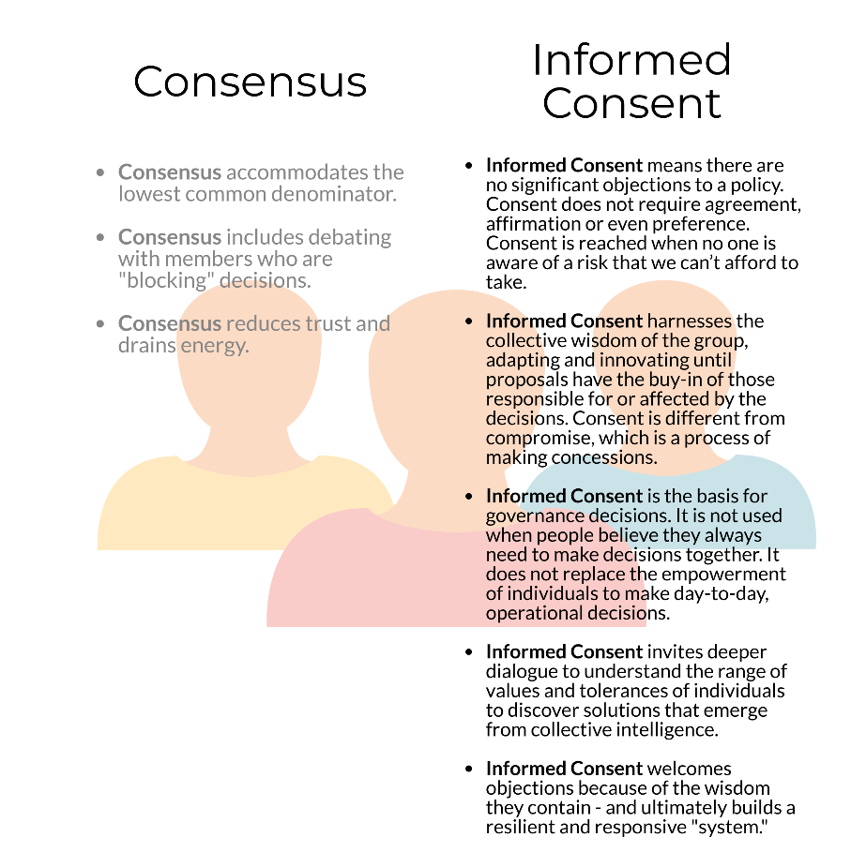

Charter Signatories
The Project Team shared the list of individuals and organizations that affirmed their desire to be charter signatories to the Partnership. Of these 30 individuals, 29 agreed to participate in the January and February strategy development meetings. It was noted that Alexandria would reach out to signatories that originally signed the charter and affirm their interest and participation. The Project Team was also asked to ensure the original signatories to the charter and Partnership be retained on the website for historical accuracy.

Don | Andre | Oregon Coast Community Forest Association
Jeanne | Anstine | Newport Community Gardens
Caylin | Barter | Wild Salmon Center
David | Bayus | Johnson Creek Water Services Company
Jennifer | Beathe | Starker Forests, Inc.
Shannon | Beaucaire | City of Yachats
Mike | Broili | MidCoast Watersheds Council
Harmony | Burright | OWRD
Suzanne | de Szoeke | GSI Water Solutions, Inc.
Adam | Denlinger | Seal Rock Water District
Alan | Fujishin | Gibson Farms
Timothy | Gross | Civil West Engineering Services, Inc.
Evan | Hayduk | MidCoast Watersheds Council
Jen | Hayduk | Lincoln Soil and Water Conservation District
Chris | Janigo | City of Newport
Penelope Kaczmarek | Kaczmarek | interested citizen
Jay MacPherson | MacPherson | Oregon Health Authority
Tim | Miller | Lincoln County Farm Bureau
Cinamon | Moffett | Hatfield Marine Science Center
Bill | Montgomery | interested citizen
Clare | Paul | City of Newport
Lisa | Phipps | DLCD
Paul | Robertson | Robertson Environmental
Mark | Saelens | Saelwood LLC
Greg | Scott | City of Yachats
Billie Jo | Smith | Interested citizen. (Former Toledo Mayor)
John | Spangler | Oregon Fish and Wildlife
Matt | Thomas | Oregon Department of Forestry
Stan | van de Wetering | Confederated Tribes of the Siletz Indians of Oregon
David | Waltz | OR DEQ, Nonpoint Source and Drinking H₂O Protection Programs
Geoffrey | Wilkie | Interested citizen

Lisa DeBruyckere will be distributing the dates and Outlook announcements for the January and February strategy development meetings by close of business tomorrow.

Draft Action Plan Tables
The Project Team walked through the process they will use in January and February to develop draft strategies – the process was included in the monthly newsletter to the partnership.

Next Meeting
The next meeting of the Coordinating Committee is January 14, 2021 from 9am-10am.

