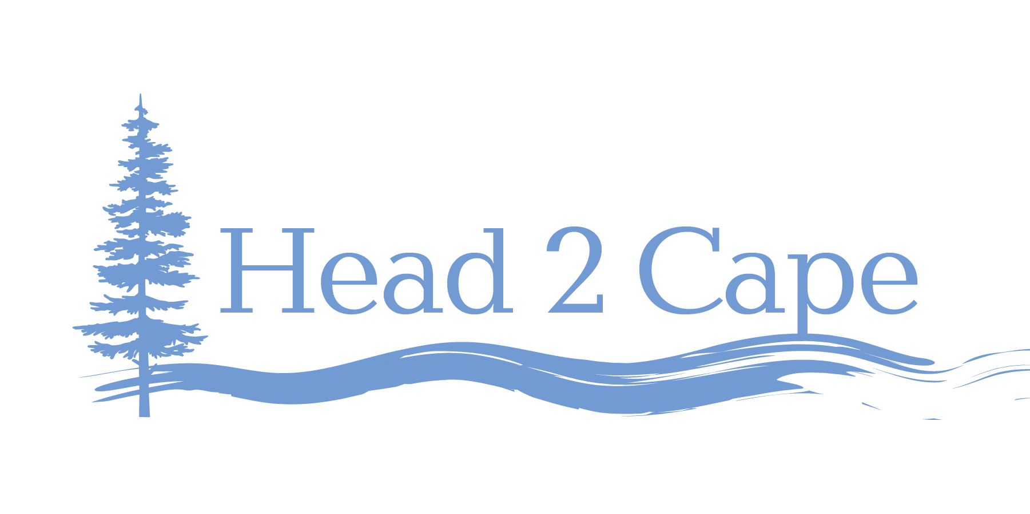

AGENDA

Mid-Coast Water Planning Partnership Strategy Development

Session #4: Ecosystem Protection and Enhancement
January 27, 2021 8:00am–9:30am

Please join my meeting from your computer, tablet or smartphone.
https://global.gotomeeting.com/join/756758117

Objective: Develop draft strategies that address the key issues associated with Ecosystem Protection and Enhancement in the Mid-Coast region of Oregon.

Ecosystem Protection and Enhancement
- Opportunities exist in the Mid-Coast for enhancing beaver habitat and management to improve water storage, stream health, and support the recovery of key native fish species.
- Degraded riparian areas throughout the Mid-Coast negatively affect water quality, wildlife habitat, and overall watershed health. Opportunities exist to improve these areas.
- Summer streamflows are insufficient in some areas of the Mid-Coast to meet the instream water needs of fish and wildlife. Low streamflows contribute to water quality impairments (e.g., high temperatures) that negatively affect fish and wildlife.
- Many streams in the Mid-Coast lack: 1) legal protections (e.g., instream water rights) to protect streamflows for the full range of ecological flows, and 2) streamflow targets to guide instream flow restoration efforts where there are already significant out-of-stream uses.
- Some watershed systems, such as the Siletz, have insufficient water to meet the needs of all uses (both instream and out-of-stream) leading to ecological impacts on the rivers, insecurity for water users, and the potential for conflict.​
- Multiple river and stream segments consistently do not meet Oregon and federal water quality standards: high temperature and low dissolved oxygen threaten fish, and elevated turbidity affects the ability to treat and use water.

8:30am–8:35am Welcome, introductions

8:35am–8:40am Review of key objectives, definition, and key issues from Step 3 of the Planning Process

8:40am–9:25am Review/affirm/edit draft strategies/actions discussed by partners to date, and consider other potential actions.

9:25am–9:30am Summarize, discuss goals for next week, and adjourn

Table 4. Ecosystem Protection and Enhancement states, objectives, and actions to address key water issues in the Mid-Coast region of Oregon.
States | Objectives | Actions Discussed by Partnership To Date | Potential Actions to Consider/Incorporate
Reduced health of watersheds and degraded riparian areas/insufficient buffers.  Insufficient habitat to facilitate recovery of key native fish species. | Restore watershed ecological function (ridgetop to river approach) (Oregon stream function assessment definitions – coming from Dave W.):  - Restore riparian areas and instream habitats.  - Re-establish hydrologic regimes (and sediment transport regimes) to a more natural state. | - Advocate for the implementation of watershed restoration projects that cool streams and improve summertime flows, especially in streams identified as priorities in the Mid-Coast.  - Work with the Oregon Invasive Species Council, local watershed groups, and others to identify high priority invasive species in each watershed, and seek funding to support control and management of these species.  - Prioritize streams reaches for buffer establishment and improvement using the Department of Environmental Quality’s Heat Source and other models as well as local knowledge of these streams and reaches.  - Plant and protect Ensure there are woody buffers along streams to maintain water quality and ensure ecological function, and produce habitat for beavers.  - Control/remove invasive vegetation along stream corridors (e.g., reed canary grass, Himalayan blackberry, Asian knotweeds) to encourage establishment of native trees and shrubs.  - Conduct habitat restoration using native plants. | - Advocate for incentives, and other strategies, that promote silvicultural practices that support restoration of watershed ecological function and protect drinking water source areas.  - Connect private landowners with local stewardship foresters, local SWCD staff, and USDA NRCS staff, OSU Extension, and others to access resources and information (Oregon Plan for Salmon and Watersheds – connects #1 and 2).  - Limit future structural development on floodplains to reduce impacts on riparian areas.  - Manage riparian area vegetation by planting native trees, encouraging promoting a diversity of successional stages and species in riparian corridors (including an adequate representation of late-successional forest stages) rapid development of late-successional forest stages (where needed), augmenting large wood to achieve ecological goals, and excluding livestock/other changes in grazing management.  - Advocate for the implementation of voluntary, incentive-based actions in the Agricultural Water Quality Management Plan.  - Support the Aquatic Invasive Species Prevention Program.  - Support the Oregon Conservation Strategy’s seven statewide actions to prevent new invasive species introductions, and decrease the scale and spread of infestations  - Prevent the introduction of new invasive species through collaborative efforts, such as watercraft inspection stations.  - Increase public awareness and reporting of invasive species.  - Develop early detection and rapid response plans to facilitate swift containment of new introductions.  - Establish a system to track to the location, size, and status of priority invasive species.  - Focus eradication efforts in Oregon Conservation Strategy Habitats and other high priority areas.  - Assess the ecological impact and management approaches for priority invasive species.  - Share information on management controls with landowners and land managers.  - Update development standards to use green infrastructure methods, including urban forests and riparian buffers, to decrease and treat stormwater runoff and protect stream systems.  - Flood attenuation and summertime-flow augmentation  - Increase water retention in channel upstream via re-meandering, addition of large wood and coarse sediment, reopening of side channels, replacing road culverts with bridges, removal of physical structures (dams), decreasing bank slopes, and encouraging beaver activityintroducing beaver.  - Increase water retention capacity in the floodplain upstream by reconnecting via installing new floodplains, implementing Stage 0 and Stage 8 restoration (address incised downcut channels), and enhancing and reconnecting riparian wetlands, and dry buffer strips.  - Increase water retention capacity in upstream and adjacent uplands via upland wetlands, forest planting and revegetation, and green roofs/green areas and underground water storage areas (urban areas).
Inadequate water availability to meet instream and out-of-stream uses. | Identify, meet, protect, and restore peak and ecological flows. | - Determine ecological flows and establish in-stream needs.  - Incentivize acquiring instream water rights from willing sellers and transferring those to in-stream use.  - Require a reporting system for water rights. | - Designate Scenic Waterways where needed to protect recreation, fish, and wildlife uses.  - Designate Outstanding Resource Waters where needed to protect extraordinary water quality or ecological values .  - Establish additional instream water rights where needed to protect the full suite of flows for fish and wildlife, water quality, recreation, and scenic attraction.  - Expand the use of voluntary programs to protect and restore streamflow, lake levels, and cold water refugia.  - Expand the geographic range of flow restoration efforts by identifying flow restoration priorities.  - Require and provide assistance to install and use flow meters on all stream withdrawals. Use information to gain a more accurate estimate of water use and availability.  - Look for opportunities to collect and store water in the winter season to be used in the summer as a replacement for summer withdrawals.
POTENTIAL NEW ROW
Inadequate water storage. | Promote natural water storage in the region using beavers and green infrastructure. | - Protect beaver populations and strategically encourage beaver pond creation.  - Restore hyporheic flows (the transport of surface water through sediments in flow paths that return to surface water) by:  - Building instream structures (log jams) to capture gravels.  - Building structures to retain gravel at confluences of cooler tributaries.  - Improve streamflows and off-channel water storage by:  - Creating instream log jams to capture bedload, refill incised channels, and reconnect floodplains.  - Improving groundwater storage capacity.  - Enhance reservoir security and seek additional sources for water storage. | - Seek opportunities to collect and store water in the winter season to be used in the summer as a replacement for summer withdrawals.  - Explore opportunities for creating distributed networks of wintertime surface water storage facilities to offset summer use.
 | Balance instream and out-of-stream water uses. |  | - Develop educational materials regarding current water use and estimates of water cycle components to increase understanding of where water goes and how it is allocated. Facilitate discussions to explore opportunities to shift these uses based on updated values and priorities. What would “balance” look like? How do we get there?
 | Summer streamflows are insufficient in some areas of the Mid-Coast to meet the instream water needs of fish and wildlife. |  | 1. Consider financial incentives to trade water rights and water use for instream needs.
- Natural and nature-based engineered systems that mimic natural processes) to reduce impacts from natural hazards, stabilize shorelines, attenuate waves, reduce flooding and erosion impacts, aid in the storage of freshwater supplies, improve water quality, and enhance habitat and biodiversity.

